

College Name:-Shree Swaminarayan College Of

Technology & Management

(SSCTM),

Department Name:- Computer & IT.

Project Name:-''K&S Furniture''

Submitted By:-KAHAN MODI &

SHAHNAWAZ SANDHI

Enrollment No:-243270601028,243270601048

Semester:-lll(3)(B.C.A)

Guided By:-Anjali pawar

Academic Year:-2024-2025

Shree Swaminarayan College of Technology & Management Page=1

furniture website

on

K&S-Kahan & Shahnawaz Furniture

submited TO



Gujarat Technological University

Degree of

(B.C.A)

Bachelor of Computer Application

Year--2024-2025

Semester-3(III)

Submitted By;-

*Name:- *Roll No:-

* 1. Shahnawaz Sandhi 243270601048
  2. Kahan Modi 243270601028

Shree Swaminarayan College fo Technology &Managenent

AHMEDABAD – 382480

Website:- https://www.ssctmbca.in

Contact:- +91 63534 58734

Year:-2024-2025

Shree Swaminarayan College of Technology & Management Page=2

Email:[-ssctmbca@gmail.com](mailto:-ssctmbca@gmail.com) Contact:- +91 63534 58734

Certificate of Completion

This is to certify that the following Student of Shree Swaminarayan college of bechelor of Computer Applications, Ahmedabad from BCA Semester-3 (BCA) have satisfactory Completed Software Development Project.

''K&S Furniture Website''

As An Academic Requirement of BCA Semester-3 as a partial fulfilment of the requirement for the degree of Bachelor of Computer Application (BCA) for the academic year 2024-2025.

Name of Students = Shahnawaz Sandhi , Kahan Modi

Roll No. (College) = 243270601048 , 243270601028

Shree Swaminarayan College of Technology & Management Page=3

Index

❖ Project Profile……………………………………………………[01]

❖ Furniture Profile………………………………………………….[02]

❖ Introduction………………………………………………………..[03]

❖ Tools and Technology……………………………………………..[04]

❖ Layout……………………………………………………………..[05]

• Home Page…………………………………………………….[06]

❖ Visitor……………………………………………………………...[07]

• Category………………………………………………………..[08]

• Product……………………………............................................[09]

• Information About Wood We Use..…………………………….[10]

• Become A Partner Form.......…………………………………...[11]

• About us………………………………………………………...[12]

• Contect Us……………………………………………………....[13]

• Footer…………………………………………………………...[14]

❖ Customer side…………………………………………………......[15]

• Registration / Log in……………………………………………[16]

• Add to Cart / Product Added…………………………………...[19]

• Customer View Cart……………………………………………[20]

• View Order / Details……………………………………………[22]

❖ Social Media……………………………………………………….[23]

• Instagram / Facebook…………………………………………...[24]

❖Future scope……………………………………………………...[25]

❖ Bibliography……………………………………………………….[26]

Shree Swaminarayan College of Technology & Management Page=4

PROJECT PROFILE

|  |  |
| --- | --- |
| Project Name | Furniture Website |
| Group Member | 2 |
| Team Name | Shahnawaz Sandhi (1048)  Kahan Modi (1028) |
| Plate Form | Website |
| Institute | Shree Swaminarayan College of Techenology & Managemen |

Shree Swaminarayan College of Technology & Management Page=5

FURNITURE PROFILE

|  |  |
| --- | --- |
| Name | K&S FURNITURE |
| Owner Name | KAHAN & SHAHNAWAZ |
| Address | S/11,SINDHUBHAVAN,AHMEDABAD |
| Contect no | +91 63534 58734 |

Shree Swaminarayan College of Technology & Management Page=6

INTRODUCTION

➢ K&S Furniture is developed using HTML, CSS, and JavaScript. It is a responsive web-based project designed to offer a modern and seamless user experience across all devices.

➢ Furniture E-commerce System is the development of a platform to digitize furniture retail operations, including product catalog browsing, category filtering, and dynamic shopping cart management. It features an interactive user interface for viewing detailed product specifications, high-quality image showcases, and modules for customer inquiries and business partnerships.

Shree Swaminarayan College of Technology & Management Page=7

Tools and Technology

❖ Technology

* Front-End

1) HTML

2) css

3) javascript

* Back-End

▪ Php

▪ Bootstrap (Framework)

* Other Tools

▪ Ms word (For Documentation)

▪ Ms PowerPoint (For presentation)

Shree Swaminarayan College of Technology & Management Page=8

# Layout

• Home page

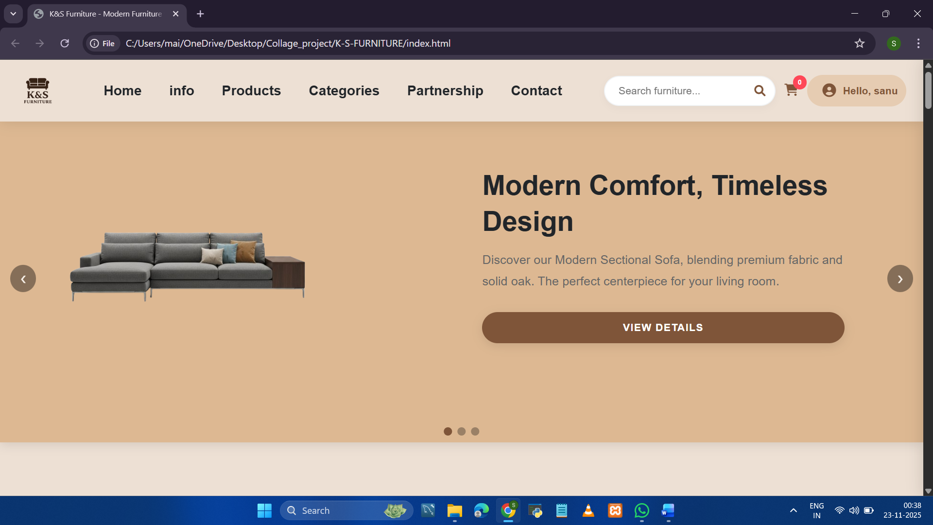

Shree Swaminarayan College of Technology & Management Page=9

Visitor

• Category

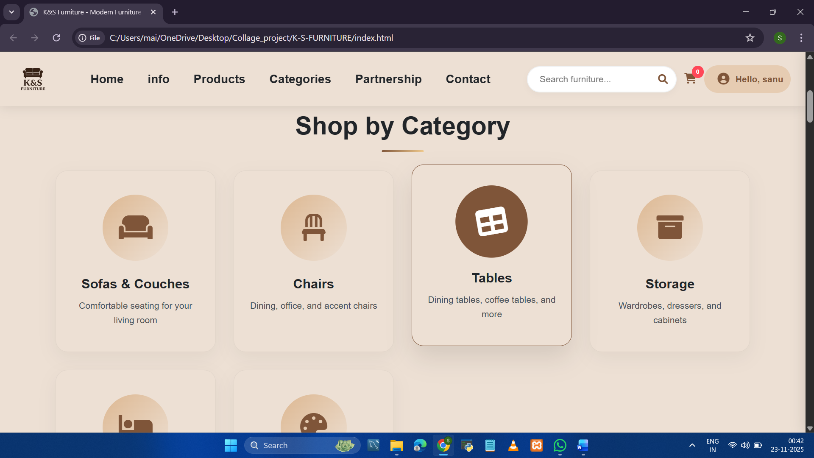

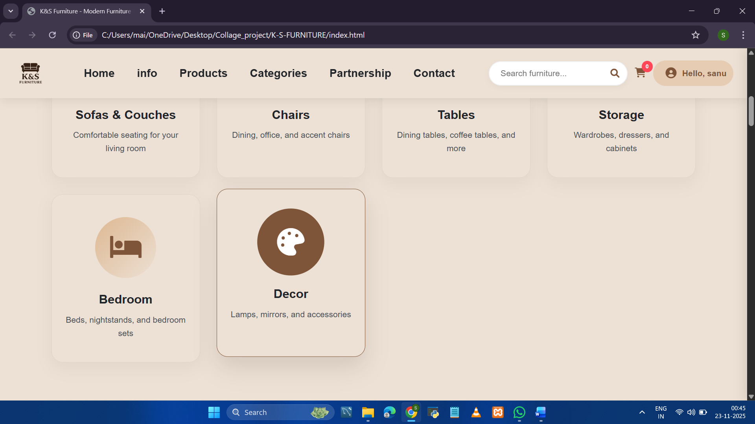

Shree Swaminarayan College of Technology & Management Page=10

• Product

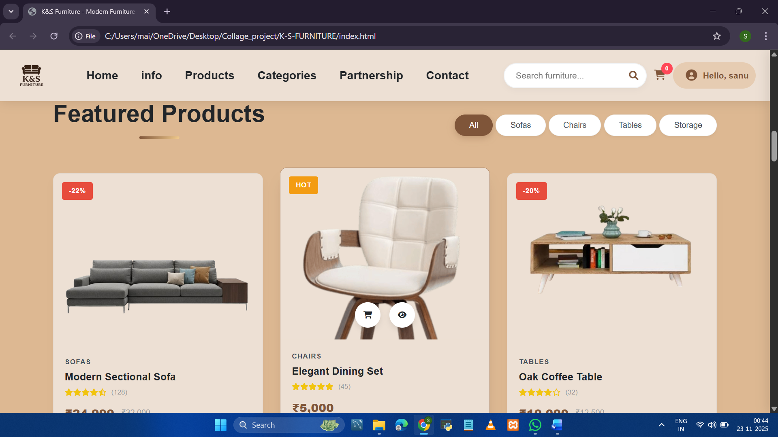

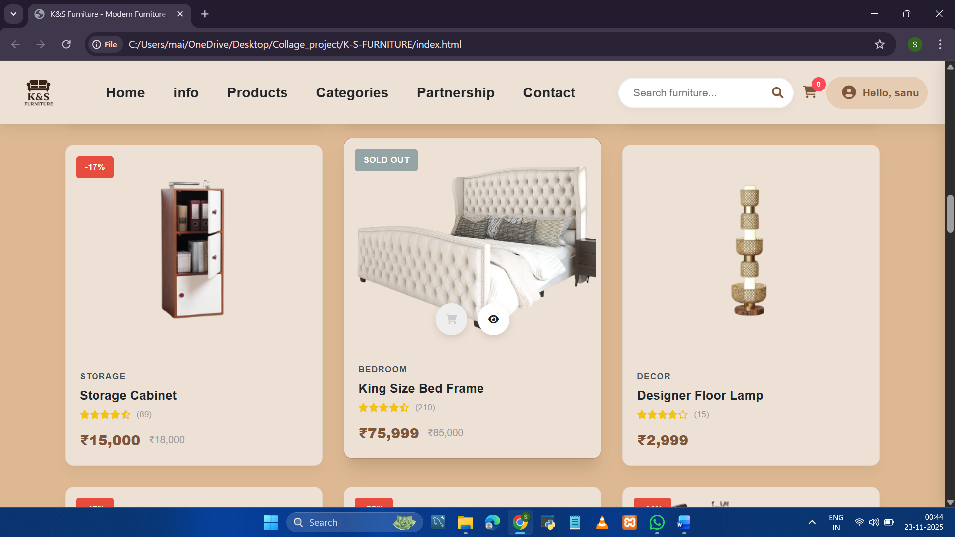

Shree Swaminarayan College of Technology & Management Page=11

• Information About Wood We Use

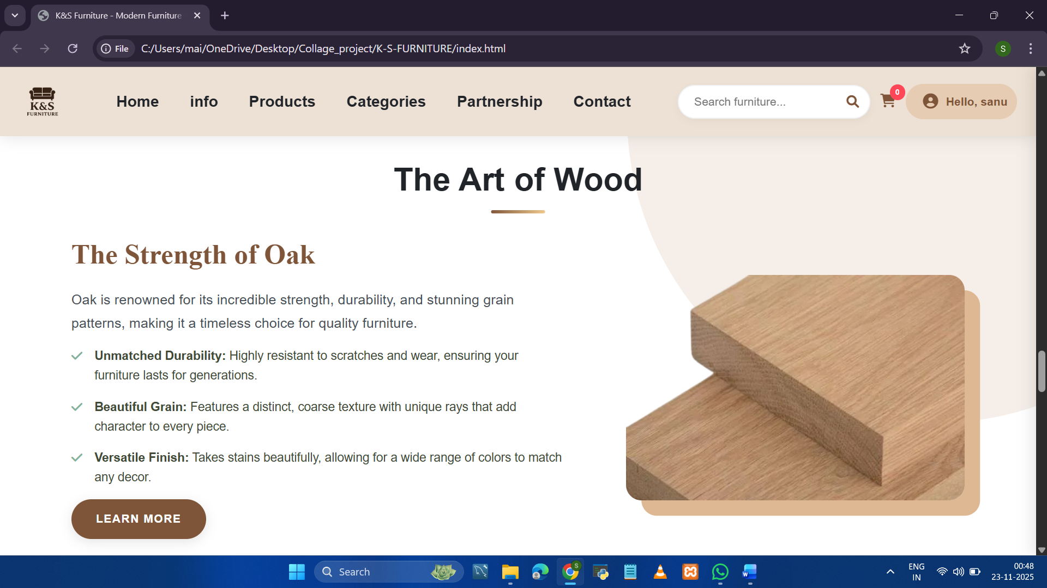

Shree Swaminarayan College of Technology & Management Page=12

• Become A Partner Form

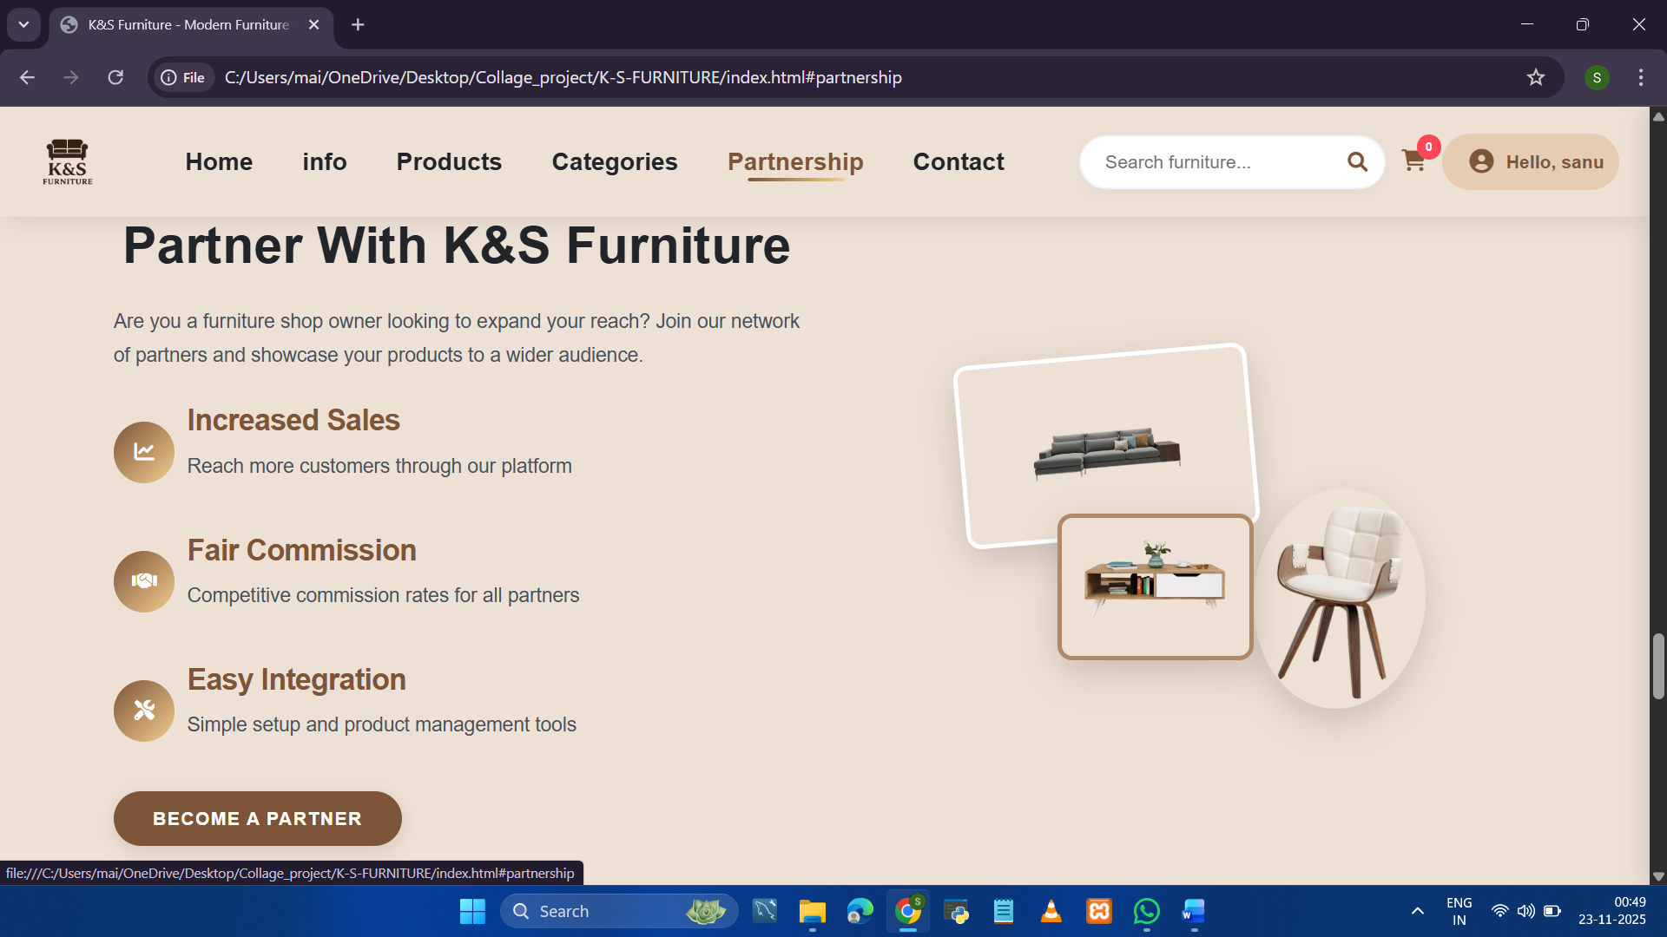

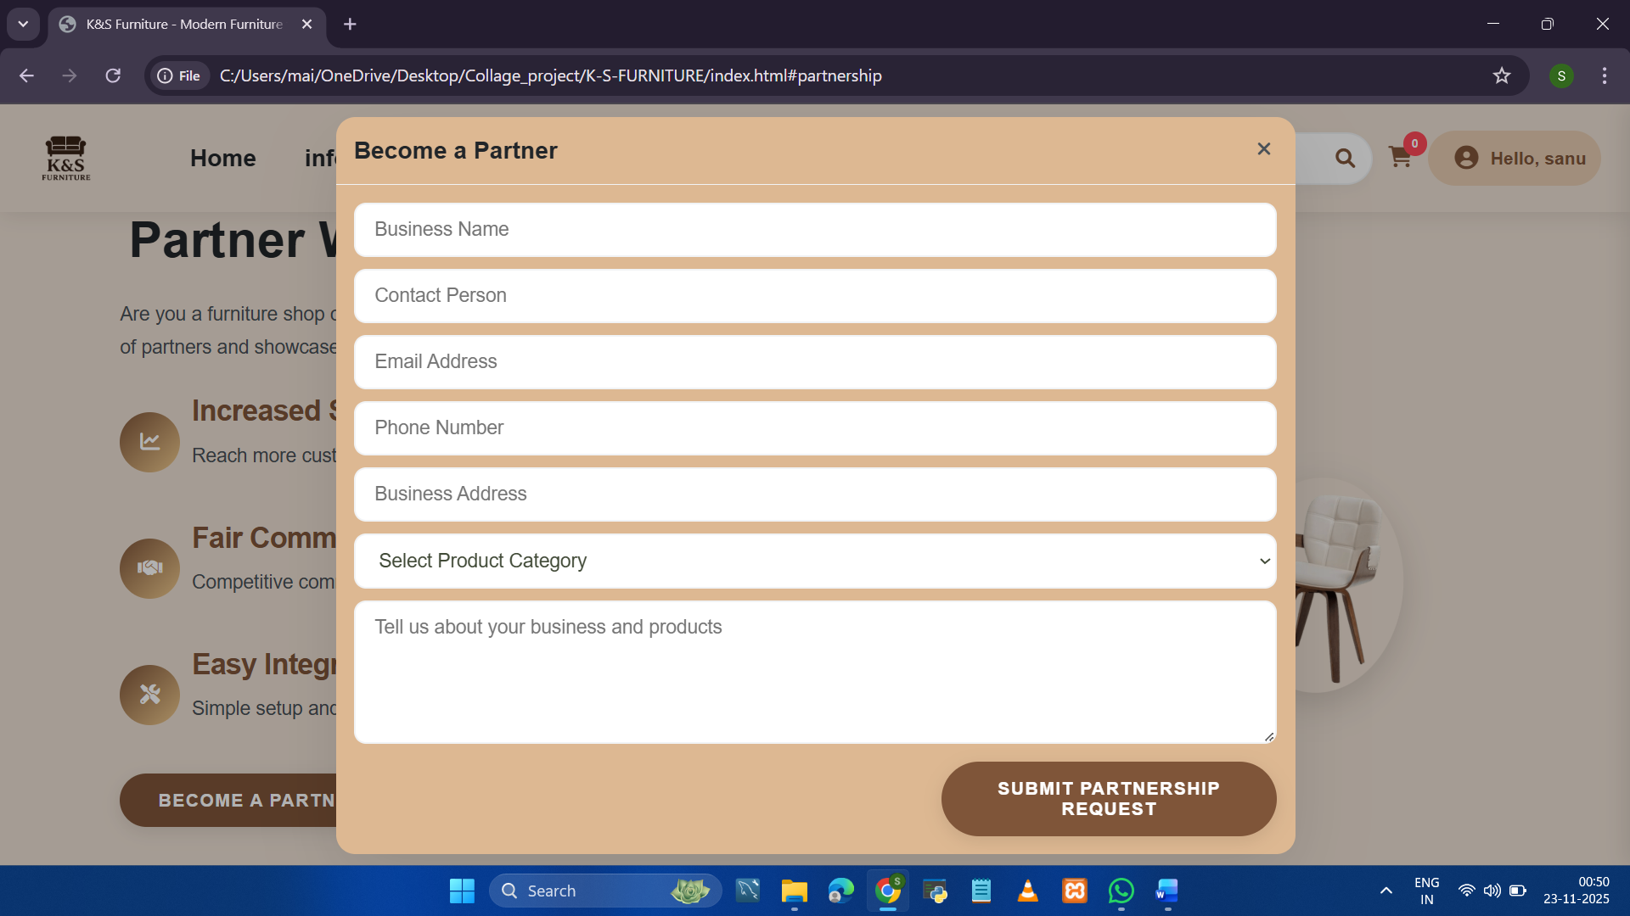

Shree Swaminarayan College of Technology & Management Page=13

• About us

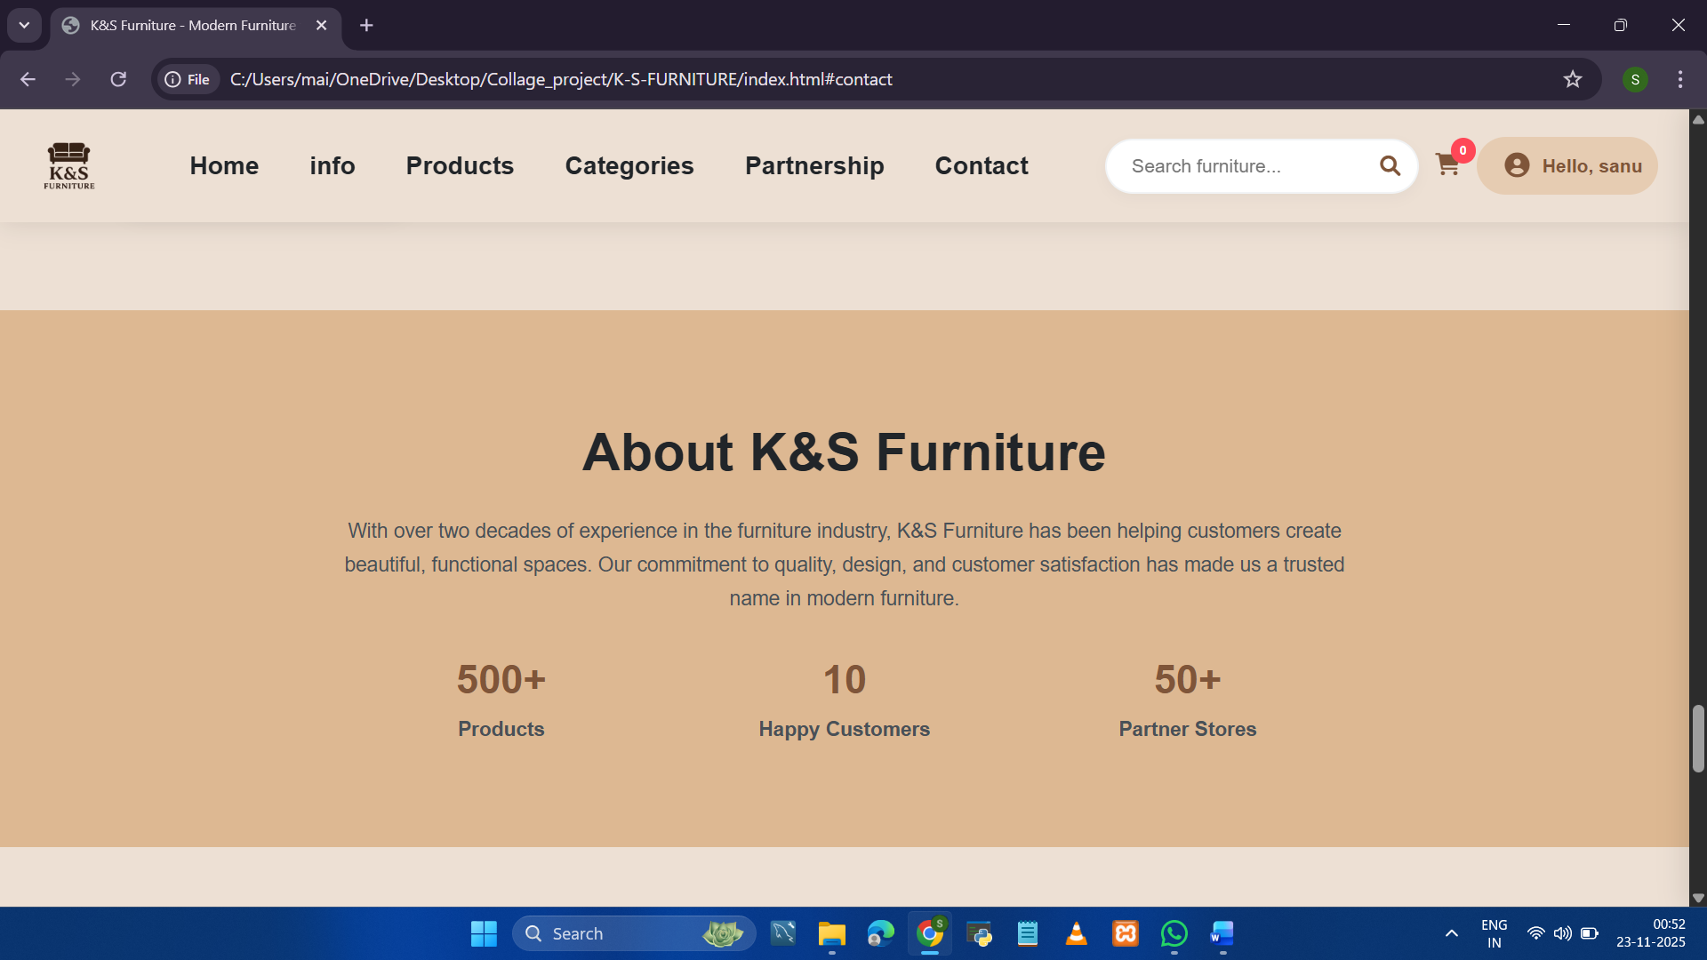

Shree Swaminarayan College of Technology & Management Page=14

• Contact Us

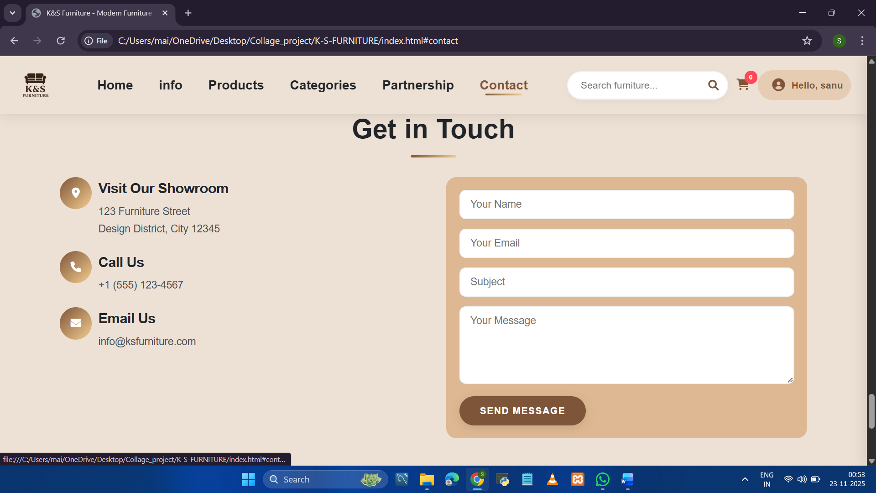

Shree Swaminarayan College of Technology & Management Page=15

• Footer

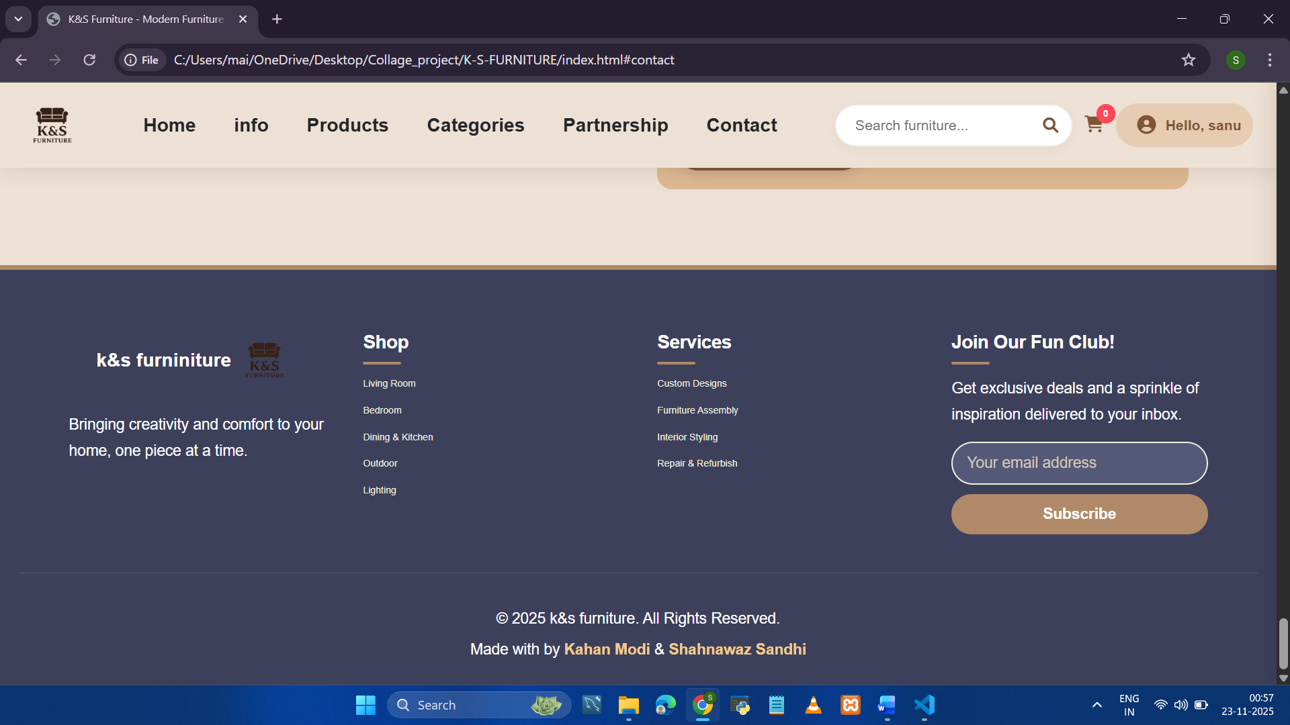

Shree Swaminarayan College of Technology & Management Page=16

Customer side

• Registration / Log in

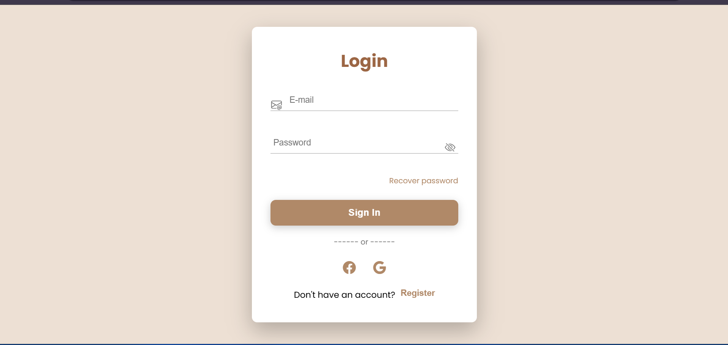

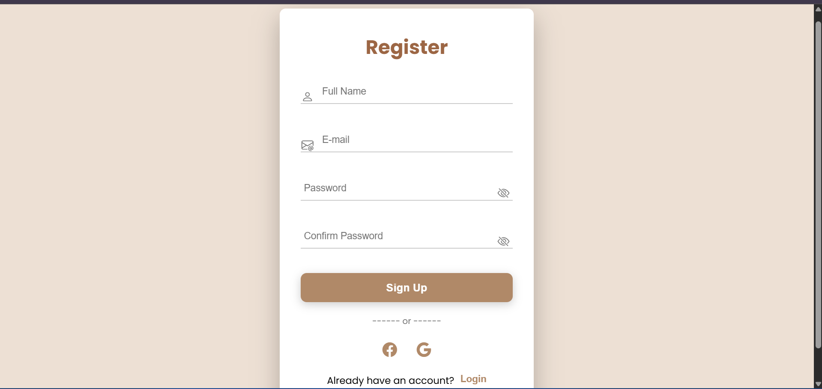

Shree Swaminarayan College of Technology & Management Page=17

• Add to Cart / Product Added

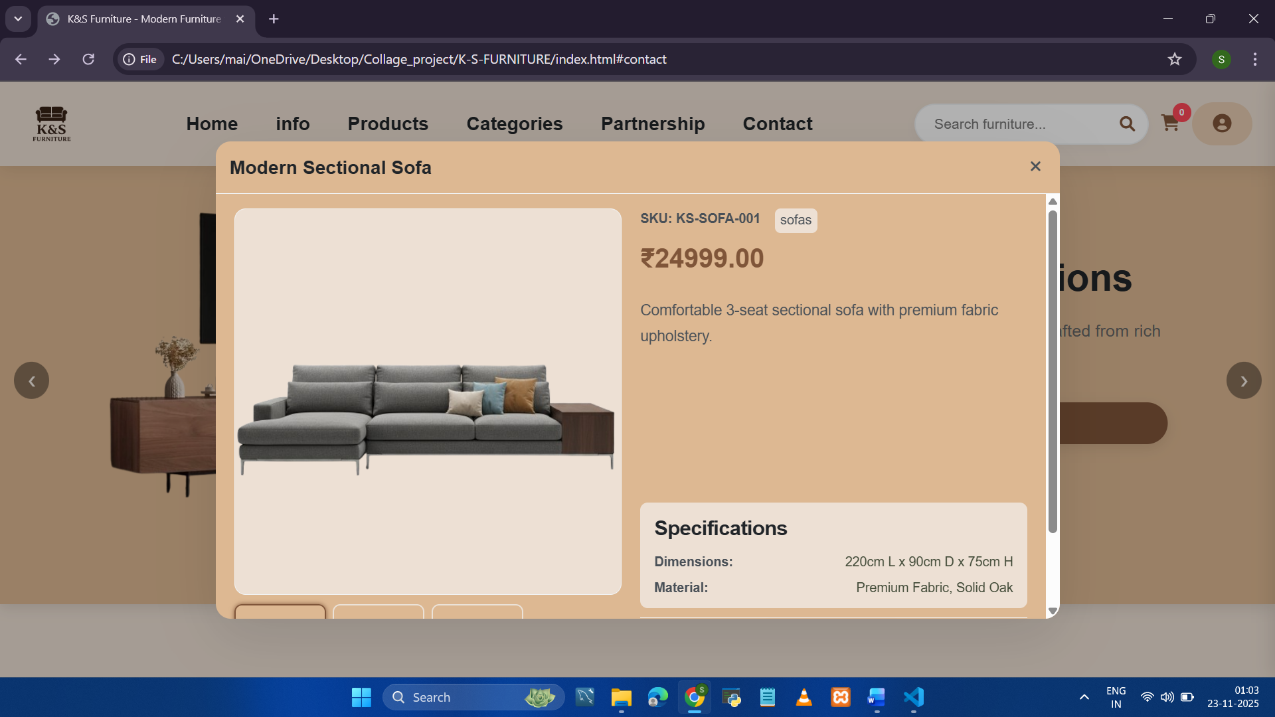

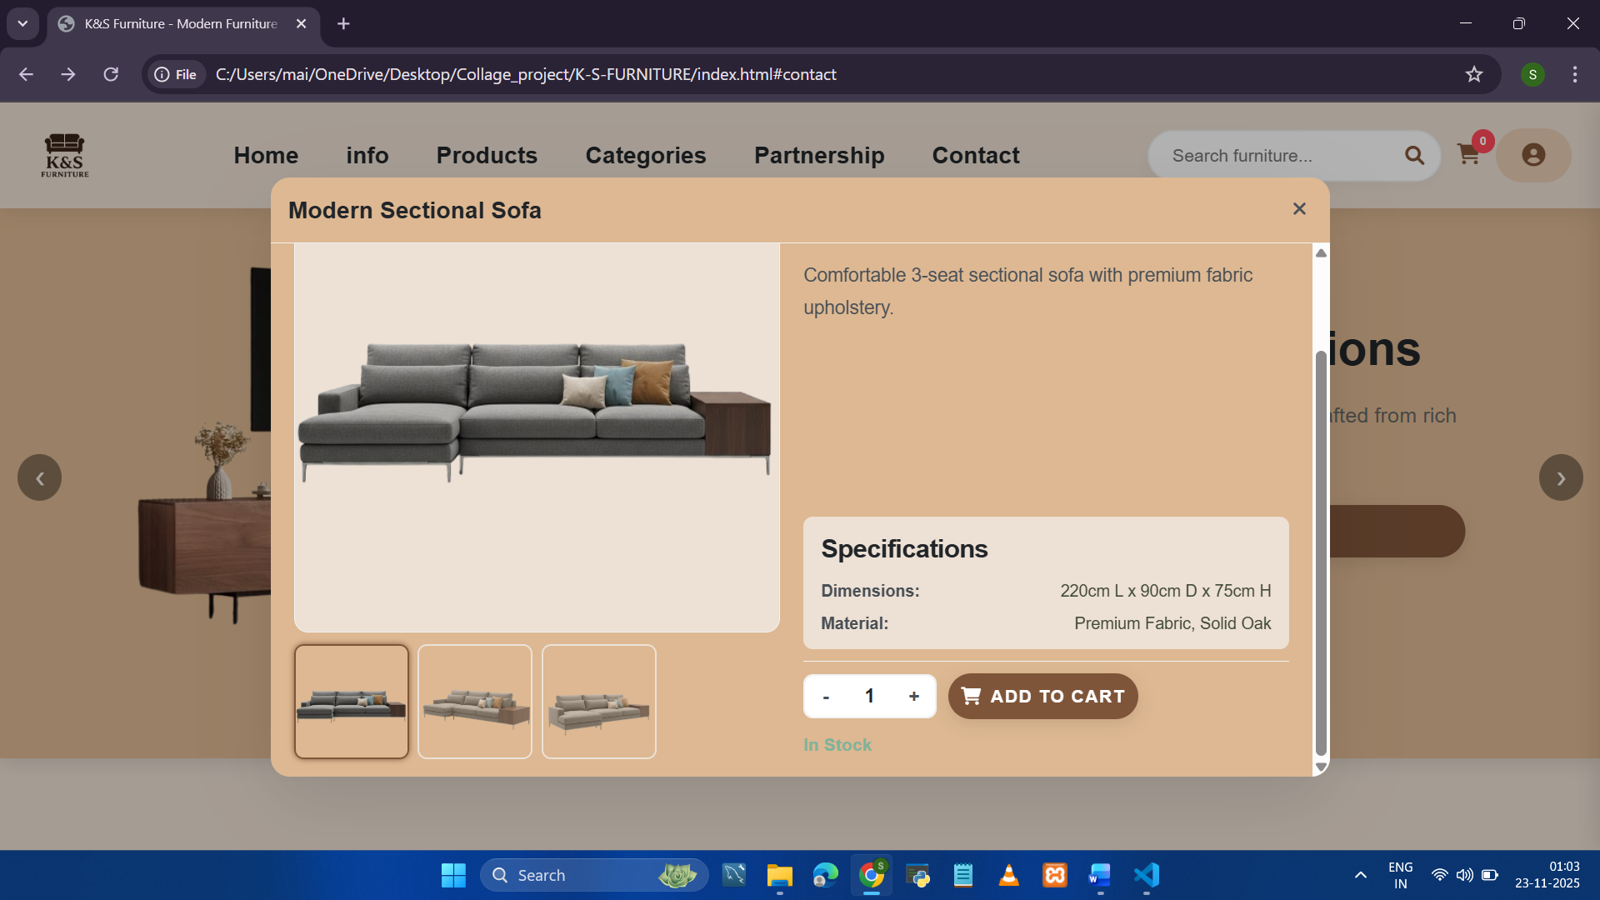

Shree Swaminarayan College of Technology & Management Page=18

• Customer View Cart

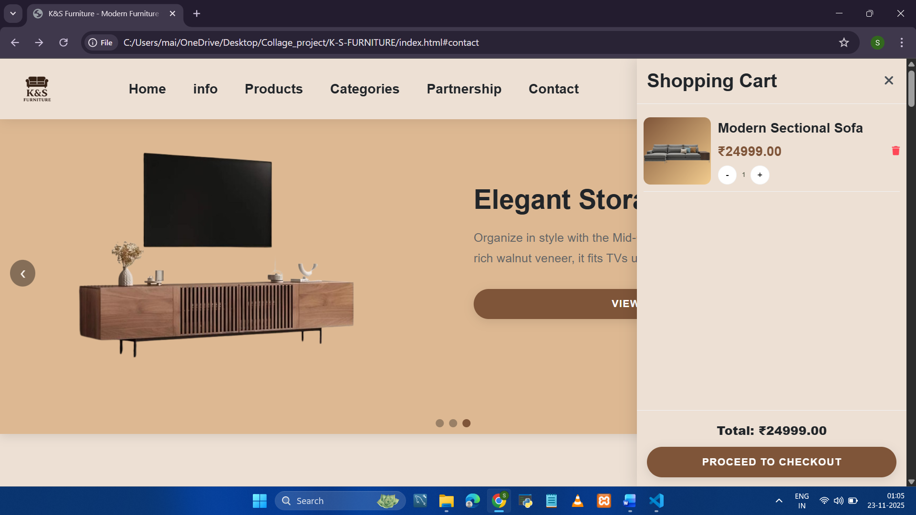

Shree Swaminarayan College of Technology & Management Page=19

• View Order / Details

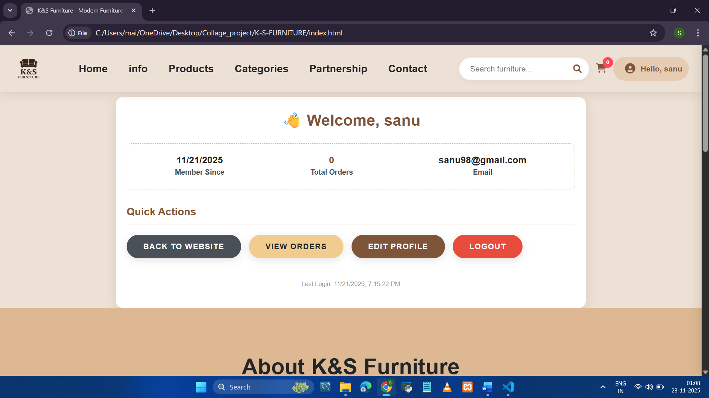

Shree Swaminarayan College of Technology & Management Page=20

Future scope:

While the current system is fully functional as a frontend application, the following features are planned for future versions:

1. **Backend Integration:** Implementing Node.js and MongoDB to replace LocalStorage for secure, server-side data management.
2. **Payment Gateway:** Integrating Stripe or Razorpay for processing real credit card transactions.
3. **Order Tracking:** A live tracking system for delivery status.
4. **Augmented Reality (AR):** Allowing users to use their phone camera to see how furniture looks in their room.

Shree Swaminarayan College of Technology & Management Page=21

Bibliography

**Web References:**

1. **W3Schools** (HTML/CSS Documentation) - [*www.w3schools.com*](https://www.w3schools.com)
2. **MDN Web Docs** (JavaScript Reference) - *developer.mozilla.org*
3. **FontAwesome** (Icons) - *fontawesome.com*
4. **Google Fonts** (Typography) - *fonts.google.com*

**Books & Notes:**

1. "Head First HTML and CSS" by Elisabeth Robson and Eric Freeman.
2. College Laboratory Manuals and Lecture Notes.

Shree Swaminarayan College of Technology & Management Page=22